|  |
| --- |
|  |
| 新概念 3 册 |
| Lesson16 Mary had a little lamb |

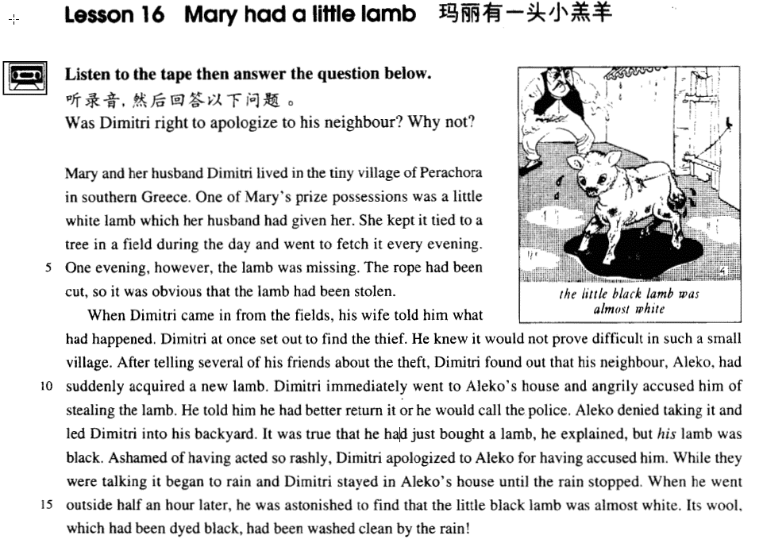

课文

Mary and her husband Dimitri lived in the tiny village of Perachora in southern Greece.

玛丽与丈夫迪米特里住在希腊南部一个叫波拉考拉的小村庄里。

One of Mary's prize possessions was a little white lamb which her husband had given her.

玛丽最珍贵的财产之一就是丈夫送给她的一只白色小羔羊。

She kept it tied to a tree in a field during the day and went to fetch it every evening.

白天，玛丽把羔羊拴在地里的一颗树上，每天晚上把它牵回家。

One evening, however the lamb was missing.

可是，一天晚上，那只小羔羊失踪了。

The rope had been cut, so it was obvious that the lamb had been stolen.

绳子被人割断，很明显小羔羊是被人偷走了。

When Dimitri came in from the fields, his wife told him what had happened.

迪米特里从地里回来，妻子把情况跟他一说，

Dimitri at once set out to find the thief.

他马上出去找偷羔羊的人。

He knew it would not prove difficult in such a small village.

他知道在这样一个小村庄里抓住小偷并不困难。

After telling several of his friends about the theft, Dimitri found out that his neighbour, Aleko, had suddenly acquired a new lamb.

把失窃的事告诉几个朋友后，迪米特里发出他的邻居阿列科家突然多了一只小羔羊。

Dimitri immediately went to Aleko's house and angrily accused him of stealing the lamb.

迪米特里立刻去了阿列科家，气呼呼地指责他偷了羔羊，

He told him he had better return it or he would call the police.

告诉他最好把羊交还，否则就去叫警察。

Aleko denied taking it and led Dimitri into his backyard.

阿列科不承认，并把迪米特里领进院子。

It was true that he had just bought a lamb he explained, but his lamb was black.

不错，他的确刚买了一只羔羊，阿列科解释说，但他的羔羊是黑色的。

Ashamed of having acted so rashly, Dimitri apologized to Aleko for having accused him.

迪米特里为自己的鲁莽而感到不好意思，向阿列科道了歉，说是错怪了他。

While they were talking it began to rain and Dimitri stayed in Aleko's house until the rain stopped.

就在他俩说话的时候，天下起了雨，迪米特里便呆在阿列科家里避雨，一直等到雨停为止。

When he went outside half an hour later, he was astonished to find that the little black lamb was almost white.

半小时后，当他从屋里出来时，他惊奇地发现小黑羔羊全身几乎都变成白色。

Its wool, which had been dyed black, had been washed clean by the rain!

原来羊毛上染的黑色被雨水冲掉了！

词汇讲解

* **prize** [praɪz] adj. 心爱的，受珍视的

**prize / prized adj. 心爱的**

* One of Mary's prize possessions was a little white lamb which her husband had given her.
* The idea never appealed to me very much, but one day, after a heavy shower, I happened to be walking in my garden when I noticed a huge number of snails taking a stroll on some of my prize plants.

**valued** / **treasured** / **cherished** adj. **(对某人有特殊意义，本身未必值钱)**

**prize / value / treasure / cherish** vt. 珍爱，珍视

* I’ll **prize / value / treasure / cherish** our friendship for ever.
* This is a lesson you’re going to **prize / value / treasure / cherish**.

**valuable / priceless / precious** adj. 宝贵的，价值连城的 **（强调本身很值钱）**

**precious stone** 宝石

* It was very old and precious even then.
* **tie** [taɪ] v. 拴，系
* tie a tie 系领带

**tie … to …** 把…绑（拴）住

* **Tie** the horse **to** a tree.
* The thief was **tied / bound(bind) / chained(chain)** to a tree.
* **theft** [θeft] n. 盗窃

**theft** n. 盗窃

**thief** n. 贼)

* He is guilty of **theft**.

**burglary n. 入户行窃**

**burglar n. 梁上君子**

* **Burglar** alarms going off at any time of the day or night serve only to annoy passers-by and actually assist burglars to **burgle**.

**pickpocket *n.*** 扒手

**shoplifter *n.*** 商店扒手

**steal sth. from sb.** 从某人偷窃

**rob sb. of sth.** 抢窃某人

**help oneself to sth.**  偷/抢某事

* One of the thieves was struck by a heavy statue, but he was too busy **helping himself to diamonds** to notice any pain.

**poach *vt.*** 水煮；偷猎；窃取；把…踏成泥浆 ***vi.*** 偷猎；侵犯；剽窃

* Deer have been poached here for years.

**embezzle *vt.*** 盗用；挪用；贪污

* The official was charged with **embezzling** enormous government funds.
* **accuse** [ə'kju:z] **v. 指控；（愤怒地）指责**

**accuse sb. of sth.** 指控/指责某人

* I **accused** him of stealing my sheep.
* Dimitri immediately went to Aleko's house and angrily **accused** him of stealing the lamb.
* They may even **accuse** them of disloyalty, or make some spiteful remark about the friends' parents.

**criticize sb. for sth.** 因为某事指责某人

* He was criticized for his delay in dealing with the matter.

**censure sb. for sth.** 严厉的批评某人

* Ministers were **censured** **for** their lack of decisiveness during the crisis.

**scold sb. for sth.** (大人对小孩) 批评某人

* His mother **scolded** him **for** breaking her favorite vase.

**blame sb. for sth.** 指责某人（强调责任）

**blame sth. on sb.** 指责某人 （强调责任）

* They **blamed** George **for** the failure.
* They **blamed** the failure **on** George.

**reprimand sb. for sth.** (上级对下降) 批评某人

* I was **reprimanded** by my manager **for** being late.
* Recognizing who the customer was, the manager was most apologetic and **reprimanded** the assistant severely.

**condemn A for** 因为…谴责

**condemn as B** 谴责…是

* The movie was **condemned for** its sexism.
* The terrorist attack was **condemned** **as** an act of barbarism and cowardice.
* **deny** [dɪ'naɪ] v. 否认

**deny + sth. / doing / that …** 否定（做）某事

* He denied the charge. / knowing about it./ that he had stolen the sheep.

**admit / acknowledge + sth. / doing / that …** 承认某事

* He admitted / acknowledged the charge. / knowing about it. / that he had stolen the sheep.
* **ashamed** [ə'ʃeɪmd] adj. 惭愧的，羞耻的

**be ashamed of …** 对…羞愧的

* You should be ashamed of your behavior.

**be ashamed to do** 耻于做某事

* Their behavior makes me ashamed to be Chinese!

**shame *vt.*** 使丢脸，使羞愧

**disgrace *vt.*** 使……失宠；给……丢脸；使……蒙受耻辱；贬黜

**humiliate *vt.*** 羞辱；使…丢脸；耻辱

**bring shame / disgrace on …**

* His behavior shamed / disgraced / humiliated / brought shame on / brought disgrace on his family.

**shame** n. 羞耻；可惜

* Shame on you!
* What a shame!
* —John is sick and can’t come to class.
* —What a shame!
* **听力真题**

A) The man will be sorry later.

B) The camera should be thrown away.

C) It's too bad the camera didn't work.

D) Sarah was quite embarrassed.

M: Just as Sarah was opening the present I realized the camera wasn’t working.

W: **What a shame!**

Q: What does the woman mean?

Answer: (C) It's too bad the camera didn't work.

**put sb. / sth. to shame** 使……相形见绌

* They have all been **put to shame** by a boy who, while playing truant, travelled 1,600 miles.
* **apologize** [ə'pɒlədʒaɪz] v. 道歉

**apologize to sb. for sth.** 因某事对某人道歉

* I apologized to him for being late.

**make an apology to sb. for sth.**  因某事对某人道歉

**say sorry to sb. for sth.** 因某事对某人道歉

**be apologetic about sth.** 因某事对某人道歉

* He was **apologetic** about his late arrival.
* Recognizing who the customer was, the manager was most **apologetic** and reprimanded the assistant severely.

课文讲解

**Mary had a little lamb** 儿歌

# Mary and her husband Dimitri lived in the tiny village of Perachora in southern Greece.

知识点（一）

**in southern Greece = in the south of Greece**

**southern … = the south of …**

**northern … = the north of …**

**eastern … = the east of …**

**western … = the west of …**

**northeastern … = the northeast of …**

**northwestern … = the northwest of …**

**southeastern … = the southeast of …**

**southwestern … = the southwest of …**

* She comes from western China. 她来自中国西部。
* She comes from the west of China. 她来自中国西部。
* **造句**：Jane 和父母亲住在中国东北一个叫丹东的小城市里。
* Jane and her parents live in the tiny town of Dandong in northeastern China.
* Jane and her parents live in the tiny town of Dandong in the northeast of China. Greece

知识点（二）

**Greek** 希腊

**Greek mythology** 希腊神话

* It’s all Greek to me. 我完全不懂

# One of Mary's prize possessions was a little white lamb which her husband had given her.

**prize: prized / treasured / valued / cherished**

**valuable / priceless / precious**

**语法：形容词的顺序**

**大小 形状 年龄 新旧 颜色 国际 材料 用途 + 中心名词**

* **举例**：一张新的很沉的黑色的中国式的圆形的大木餐桌
* a heavy big round new black Chinese wooden dining table
* **课文写法替换：**

… a little white lamb which had been a present from her husband.

* 课后习题讲解：

5 - was a little white lamb which had been ___D___ from her husband. (11.2-3)

(a) present (b) presented (c) presenting (d) a present

# She kept it tied to a tree in a field during the day and went to fetch it every evening.

**keep + 宾语 + 宾补 (adj. / 分词 / 介词短语)**

* The coat will keep you warm.
* He kept the fire burning.
* It’s rude to keep people waiting.
* Keep your nose out of my affairs!

**bring** 带过来

* He brought a friend to my home.

**take** 带走

* Don’t forget to take an umbrella.

**fetch** （英式）**/ get**（没事）到那去再拿回来来

* Please fetch / get me some coffee. Go fetch!

# One evening, however the lamb was missing.

**表达“丢了”**

**be missing** / **be lost** / **disappear (without trace)**

* …, the lamb was lost.
* …, the lamb **disappeared (without trace).** 消失的无影无踪

# The rope had been cut, so *it* was obvious *that the lamb had been stolen*.

**表达“显然”**

…, so it was **clear** / **obvious** / **apparent** / **that** the lamb had been stolen.

…, so **clearly** / **obviously** / **apparently** the lamb had been stolen.

* All the things I had packed so carefully were soon in a dreadful mess.
* **造句**：所有我仔细放在包里的东西都乱成了一团，所以显然珠宝是被偷了。
* All the things I had packed so carefully were in a dreadful mess, so it was **clear** / **obvious** / **apparent** that the jewels had been stolen.
* **造句**：所有我仔细放在包里的东西都乱成了一团，所以显然珠宝是被偷了。
* All the things I had packed so carefully were in a dreadful mess, so **clearly** / **obviously** / **apparently** the jewels had been stolen.

# When Dimitri came in from the fields, his wife told him what had happened. Dimitri at once set out to find the thief.

**set out to do**（带着目的）开始做某事

* The journalist immediately set out to obtain these important facts, but he took a long time to send them.

**表达“开始做某事”**

**begin** **to do** / **doing**

**start** **to do** / **doing**

**come to do**

* Future historians will be in a unique position when they **come to record** the history of our own times.
* When you **come to think** about it, there are only four ways you can deal with rubbish: dump it, burn it, turn it into something you can use again, attempt to produce less of it.

**get** **to do** / **to doing**

* I get to like her over the months.
* He’s got to thinking it was all his fault.
* They had a definite meaning, for they were as near as early man could **get to writing**.

**embark on sth.**

* Armed with the right tools and materials, newlyweds gaily **embark on the task** of decorating their own homes.

# He knew it would not prove difficult in such a small village.

**注意位置**

**such** **a** small village

**so** small **a** village

* such **an** interesting book
* so interesting **a** book

只能用“so”,不能用用“such”

**many** / **much** / **few** / **little**（little “少”是只用so）

* so many people
* so much time
* so few students
* so little money
* so little *a* boy
* such *a* little boy 小（little “少”是只用so）

# After telling several of his friends about the theft, Dimitri found out *that his neighbour, Aleko, had suddenly acquired a new lamb*.

知识点（一）

**tell sb. (about) sth.** 告诉某人某事

**report** / **relate** / **recount** **sth. to sb**. 告诉某人某事

* After reporting / relating / recounting the theft **to** several of his friends, …
* We know instinctively, just as beekeepers with their bees, that misfortune might overtake us if the important events of our lives **were not related to** it.
* 课后习题讲解：

10 After ____B___ the theft to several of his friends ... (1.9)

(a) telling (b) reporting (c) expressing (d) counting

知识点（二）

Dimitri found out (副词)*that his neighbour*

* The experts were now fully convinced **that** the animal was a puma, but where had it come from?

**that 从句前省略介词，**

**特殊情况：看作复合连词**

**in that … except that … but that …**

# Dimitri immediately went to Aleko's house and angrily accused him of stealing the lamb.

# He told him he had better return it *or* he would call the police.

知识点（一）

**had better do sth. or (else) ...** （威胁语气）最好…否则…

* You’d better go out at once or (else) I’ll throw you out of the window.

**do sth. before …** （威胁语气）

* Get away from here before I call the police.

**otherwise** 否则…

* Put on a heavy coat, **otherwise / or (else)** you’ll catch a cold.

知识点（二）

**had better do sth.** 表示建议（注意场合，不用于下对上）

* You’d better pay him a visit tomorrow.

You **might as well do ...** 表示建议（委婉场合）

* It might be better to do ...

**I suggest you do ..**. 表示建议（委婉场合）

知识点（三）

**call the police** 报警

**go to the police** 报警

* At first, she decided to **go to the police**, but fearing that she would never see Rastus again―the letter had made that quite clear―she changed her mind.

**inform the police** 报警

* Mrs. Ramsy was not to **inform the police** and had to pay ￡1,000.

# Aleko denied taking it and led Dimitri into his backyard.

**deny + sth. / doing / that …** 否认

* Aleko denied the accusation / charge. 否认指责，名词形式
* Aleko denied that he had taken it. 否认指责，从句形式

**admit / acknowledge + sth. / doing / that …** 承认

**lead sb.** 领某人去某地

**show sb.** 领某人去某地

* George **showed** **me** to the guestroom which, he said, was rarely used.

**usher sb.** 领某人去某地

* The secretary **ushered me** into his office.

# It was true that he had just bought a lamb, *he explained*, but his lamb was black.

**It is true that ..., but ...** 诚然…但… (先让步，再转折)

* **造句**：诚然中国还是一个发展中国家，但是她却充满了潜力。
* **It is true that** China is still a developing country, **but** she is full of potential.
* **It is true that** during their explorations they often faced difficulties and dangers of the most perilous nature, equipped in a manner which would make a modern climber shudder at the thought, **but** they did not go out of their way to court such excitement.

**相似搭配：**诚然…但… (先让步，再转折)

**It is true that ..., but ...**

**Admittedly, ..., but ...**

**Granted, …, but …**

* Admittedly, I could have tried harder, but I still don't think all this criticism is fair.
* Granted, he doesn't look too bad for his age, but I don't fancy him.
* Granted, a snobbery of camping itself, based upon equipment and techniques, already exists; but it is of a kind that, if he meets it, he can readily understand and deal with.

**让步之后，but后的表达：**

It is true that / Admittedly, / Granted, ...,

**but that is not to say that ...** 这并不少说

**but it does not follow that ...**这不一定得出这样的结论

**but it does not necessarily mean that ...** 这不对意味着

**but there is no guarantee that …** 不能保证

* **造句**：确实很多大学生选择继续读研究生 (pursue their graduate studies)，但这并不意味着他们都想做学者。
* It is true that many college students choose to pursue their graduate studies, but it does not necessarily mean that they want to be scholars.

# Ashamed of having acted so rashly, Dimitri apologized to Aleko *for having accused him*.

**语法:** Being ashamed of,非谓语当原因状语，being省略

**be ashamed of ...** 对…感到羞愧

* Being ashamed of having acted so rashly, Dimitri apologized to Aleko for having accused him.
* The gaoler looked on eagerly, (being) anxious to see if his fellow actor had at last learnt his lines.
* He used to sleep during the day and work at night, (being) quite unaware of the fact that he had become the ghost of Endley.
* (Being) Tired of sleeping on the floor, a young man in Teheran saved up for years to buy a real bed.

**语法复习：**

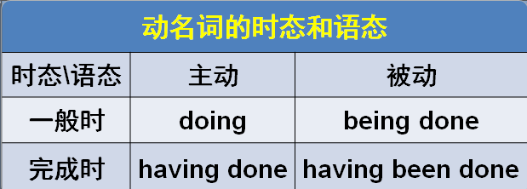.

**apologize to sb. for sth.** 向某人道歉

* Dimitri made an **apology** to Aleko for having accused him. 名词形式
* Dimitri said **sorry** **to** Aleko **for** having accused him.
* **造句**：对自己如此不小心 (inattentively) 而感到不好意思, 我为打碎了 Mary 最喜欢的花瓶而向她道歉。
* Ashamed of having acted so inattentively, I apologized to Mary for having broken her favorite vase.

# While they were talking it began to rain and Dimitri stayed in Aleko's house *until the rain stopped*.

# When he went outside half an hour later, he was astonished *to find that the little black lamb was almost white*.

**half an hour** 　半小时

**an hour and a half 一个半小时**

**表“惊讶”**

**be surprised / amazed / astonished / astounded + to find that / to learn that etc.**

* When the archaeologists reconstructed the fragments, they **were amazed to find that** the goddess turned out to be a very modern-looking woman.
* A short time ago, villagers **were astonished to learn that** the ghost of Endley had died.

# Its wool, which had been dyed black, had been washed clean by the rain!

dye sth. black / blue / blonde etc. 把…染成…颜色

* Jane has dyed her hair blonde.

**…clean** by the rain… clean 是主语补足语，修饰羊毛